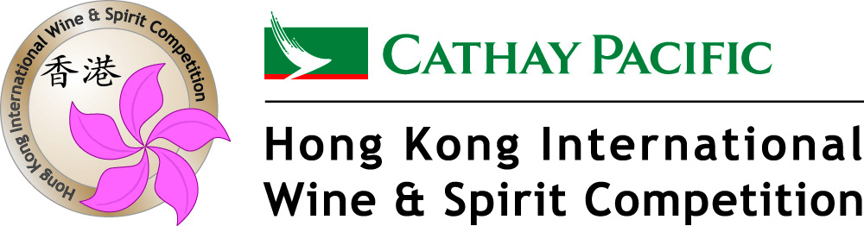

2012 CATHAY PACIFIC HONG KONG INTERNATIONAL WINE & SPIRIT COMPETITION TROPHY WINNERS

WINE VARIETALS

Best Argentinean Red Wine
Awarded to
El Porvenir de Cafayate
For
El Porveinir Red 2006

Best Australian Shiraz
Awarded to
Wolf Blass
For
Wolf Blass Platinum Label Shiraz 2007

Best Cabernet / Cabernet Blend
Awarded to
Gatt Wines
For
Gatt Cabernet Sauvigon 2009
Australia

Best Chardonnay
Awarded to
Accolade Wines
For
Hardy's Heritage Reserve Bin Chardonnay 2010
Australia

Best Italian Red
Awarded to
Umberto Cesari
For
Umberto Cesari Tauleto 2006
Italy

Best Merlot
Awarded to
SCEA du Château Brown
For
SCEA du Château Brown Red 2009
France

Best Bordeaux
Awarded to
SCEA Pierre RIVERIE
For
SCEA Pierre RIVERIE Clos des Menuts 2010
France

Best New Zealand Sauvignon Blanc
Awarded to
Sileni Estates
For
Sileni Estates Greyrock Marlborough Sauvignon Blanc 2012

Best NW Chardonnay
Awarded to
Accolade Wines
For
Hardy's Heritage Reserve Bin Chardonnay 2010
Australia

Best NW Pinot Noir
Awarded to
Cobblestone Vineyards
For
Cobblestone Pinot Noir 2009
New Zealand

Best NW Riesling
Awarded to
Seifried Estate
For
Seifried Nelson Winemakers Collection "Sweet Agnes" Riesling 2012
New Zealand

Best Semillon
Awarded to
Australian Vintage Ltd
For
McGuigan Vineyard Select Semillon 2005
Australia

Best Other Reds
Awarded to
Weingut Gunter & Regina Triebaumer
For
Weingut Gunter & Regina Triebaumer Blaufränkisch Reserve 2009
Austria

Best Other Whites
Awarded to
Domaine Sigalas SA
For
Domiane Sigalas Santorini Barrel Assyrtico 2010
Greece
Best Pinot Noir
Awarded to
Cobblestone Vineyards
For
Cobblestone Pinot Noir 2009
New Zealand

Best Riesling
Awarded to
Seifried Estate
For
Seifried Nelson Winemakers Collection "Sweet Agnes" Riesling 2012
New Zealand

Best South African Red Wine
Awarded to
Spier Wines
For
Spier Wines Naledi Caberet Sauvignon 2010
South Africa

Best Sauvignon Blanc
Awarded to
Sileni Estates
For
Sileni Estates Greyrock Marlborough Sauvignon Blanc 2012
New Zealand

Best Shiraz / Syrah
Awarded to
Wolf Blass
For
Wolf Blass Platinum Label Shiraz 2007
Australia
Best Tempranillo & Tempranillo Blends
Awarded to
Manuel Manzaneque Vineyards & Winery
For
Manuel Manzaneque Escena Red 2007
Spain

BEST STYLE CLASSES

Best Sparkling Wine
Awarded to
Champagnes P&C Heidsieck
For
Piper-Heidsieck Rare Millesimé Sparkling Wine 2002
France

Best Sweet White
Awarded to
SCEA de Bastard
For
SCEA de Bastard Mademoiselle de Clos Dady 2009
France

BEST OF ASIA

Best Wine from Japan
Awarded to
Château Mercian
For
Château Mercian Katsunuma Koshu 2011
Japan

Best Wine from China
Awarded to
Dynasty Fine Wines Group Limited
For
Dynasty Merlot Series Gold Label 2002

Best Wine with Bubbles below HK$400
Awarded to
Societa' Agricola Valdellovo s.s. di Ricci B&C
For
Anno Zero Prosecco di Conegliano-Valdobbiadene DOCG NV
Italy

Best White Wine in Hong Kong below HK150
Awarded to
SCEA du Château Brown
For
SCEA du Château Brown White 2010
France

Best Red Wine in Hong Kong below HK$200
Awarded to
Kindzmaraulis Marani
For
Kindzmaraulis Marani Mukuzani 2009
Georgia

BEST WINE WITH ASIAN DISHES
Best Wine with Sashimi
Awarded to
Château Mercian
For
Château Mercian Sparkling Katsunuma no Awa 2011
Japan
Best Wine with Kung Pao Chicken
Awarded to
Joaquin Rebolledo
For
Joaquin Rebolledo Godello 2011
Spain

Best Wine with Peking Duck
Awarded to
Pegeric Wines
For
Pegeric Pinot Noir 2007
Australia

Best Wine with Cantonese Dim Sum
Awarded to
Marisco Vineyards Ltd
For
Marisco The Ned Pinot Gris 2012
New Zealand

Best Wine with Braised Abalone
Awarded to
Jacob's Creek Wines
For
Jacob's Creek Winemakers Selection Chardonnay 2012
Australia

Best Wine with Chicken Tikka
Awarded to
Bodega Sottano
For
Sottano Judas Malbec 2009
Argentina

Best Wine with Pad Thai
Awarded to
Pisa Range Estate Vineyard
For
Pisa Range Estate Pinot Gris 2011
New Zealand

Best Wine with Tempura Shrimp
Awarded to
Château Mercian
For
Château Mercian Sparkling Katsunuma no Awa 2011
Japan

Best Wine with Beef Teppanyaki
Awarded to
Elky Wines
For
Elky Shiraz 2010
Australia

Best Wine with Yakitori Grilled Chicken
Awarded to
Château Mercian
For
Château Mercian Sparkling Katsunuma no Awa 2011
Japan

SPIRITS
Best Blended Scotch Whisky
Awarded to
Cutty Sark
For
Cutty Sark Blended Scotch Whisky Tam O'Shanter 25 YO
Scotland

Best Cognac
Awarded to
Maison Bache Gabrielson & Cie Bache
For
Gabrielsen Serenite Extra Cognac Grande Champagne 35YO
France

Best Gin
Awarded to
Vok Beverages
For
Vickers London Dry Gin
Australia

Best Grape Brandy
Awarded to
Oude Molen Distillery PTY Ltd
For
Oude Molen VOV
South Africa

Best Liqueur
Awarded to
Radeberger Destillation & Liqueurfabrik GmbH
For
Original Radeberger Bitter
Germany

Best Single Malt Scotch Whisky 15 years & under
Awarded to
Gordon & Macphail
For
Benromach Single Malt Scotch Whisky 10 YO
Scotland

Best Single Malt Scotch Whisky Over 15 Years
Awarded to
Highland Park
For
Highland Park Single Malt Scotch Whisky 21 YO
Scotland

Best Tequila
Awarded to
Embotelladora Jaral de Berrio SA de CV
For
Mezcal Jaral de Berrio
Mexico

